Over these past few months we have been thinking about making and being disciples of Jesus. If you are here regularly you’ll be familiar with this picture.
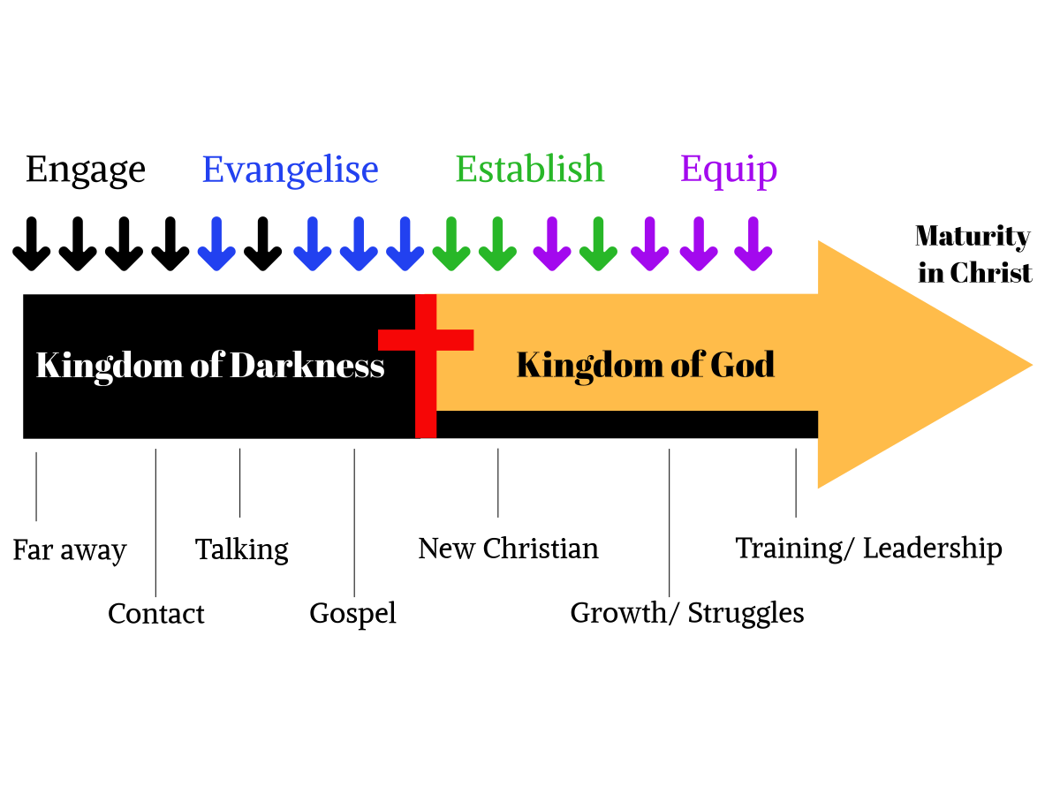

We started off contemplating the need to engage with people who don’t yet know God; then there comes a need to evangelise – to share the Good News of Jesus. After someone comes to faith there is a need to be established in that faith so that you learn what it means to be a disciple.

That’s where we are today. At the early service in Monkton we read about Peter and John reaching the empty tomb and John 20:8-9 ⁸ Finally the other disciple, who had reached the tomb first, also went inside. He saw and believed. ⁹ (They still did not understand from Scripture that Jesus had to rise from the dead.)

He believed, but he still didn’t fully understand. He had not yet worked out where the OT spoke about Messiah having to die and rise from the dead. If Peter and John didn’t get it although they had spent so much time with Jesus how were non-Jewish people supposed to understand? How are we supposed to understand?

Fortunately, God had a plan and in time one of the foremost Jewish scholars, steeped in OT knowledge and tradition was radically converted. His name was Paul and he was a brilliant preacher and teacher. He preached throughout the Northern Mediterranean and ended up in prison in Rome and it is from there he writes to the church in Colossae. They had heard the gospel from Epaphras and it appears he told Paul of the false teaching that was happening in the church and asked Paul to write to them, assuming that they would take a letter from Paul seriously. Paul’s concern is to teach them about the supremacy of Jesus and he was asked often, “Who is this Jesus?”

That is one of the most important questions anyone can ask. In fact, one day Jesus asked his disciples who people thought he was. He then made it a bit more personal Matt 16:15-17 ¹⁵ ‘But what about you?’ he asked. ‘Who do you say I am?’ ¹⁶ Simon Peter answered, ‘You are the Messiah, the Son of the living God.’ ¹⁷ Jesus replied, ‘Blessed are you, Simon son of Jonah, for this was not revealed to you by flesh and blood, but by my Father in heaven.

The church at Colossae was being infiltrated by false teachers, now known as Gnostics. They did not believe in the Trinity, or that Jesus was God or that he was born. They believed that Jesus was also a created being. There is still false teaching about Jesus today.
ISLAM: Jesus is only a prophet of Allah who was superseded by Mohamed.
BUDDHISM: Christ is not recognized as Deity.
(Zen Buddhism also does not affirm the existence of the living God.)
HINDUISM/NEW AGE: Jesus is one of many gods and a spiritual master
JUDAISM: Jesus is not divine not the Son of God and not the Messiah.
Other cults/sects:
JEHOVAH'S WITNESSES: Jesus was created as Archangel Michael, he is a lesser god; Not Jehovah God.
MORMONS: Jesus was born in heaven as the spirit child of Elohim - (The Heavenly Father) by one of his wives, and Jesus' brother was Lucifer, who became Satan. Jesus was just one of many gods.
SCIENTOLOGY – L. Ron Hubbard taught;
That Jesus was a false memory implanted into humans as a result of the Xenu space opera and that Christianity evolved from an R6 implant. Yes, I have no idea what he is on about either!!!
Many people are confused about Jesus but Paul was in no doubt. He writes this letter to the church, including us today, to teach them a number of truths about Jesus.
1. Jesus is The Image of The Invisible God vs 15 He is the image of the invisible God
An image can be two things: FIRST: It can be a representation. Paul uses the Greek word, “eikon,” which was used of the image of Caesar on a coin. The average person couldn’t see Caesar, but by looking at a coin, they could see what he looked like
• SECOND: It can be a manifestation – something theoretical or unseen made real. When the apostle Paul uses this word, he means that Jesus is the manifestation of the invisible God.
What he’s saying is that if you want to know what God is like, look at Jesus.
2. Jesus is the firstborn of all creation
V15 The Son is the image of the invisible God, the firstborn over all creation.
St Augustine was an early theologian and a hugely influential figure in the ancient Western church. He tried to capture the mystery of the Incarnation in a poem:
“Maker of the sun,
He is made under the sun.
In the Father he remains,
From his mother he goes forth.
Creator of heaven and earth,
He was born on earth under heaven.
Unspeakably wise,
He is wisely speechless.
Filling the world,
He lies in a manger.
Ruler of the stars,
He nurses at his mother’s bosom.
He is both great in the nature of God,
And small in the form of a servant.”

Should you ever get into a conversation with Jehovah Witnesses this title is one of their favourite proof verses – verses taken out of context to prove you are right and someone else is wrong! They argue that the word firstborn is proof that Jesus is a created being. However, the word can have different meanings: it could refer to someone or something that came first in order of time – the firstborn child; or, someone who is preeminent in status – Exodus 4:20 Israel is my firstborn son (Israel was not the first nation), Psalm 88:20 David is called the firstborn King of Israel but he was not the first in his family, nor was he the first King of Israel. It clearly means someone preeminent in status and that is what it means when used of Jesus, especially in light of the verses that follow v16-17 For by him all things were created: things in heaven and on earth, visible and invisible, whether thrones or powers or rulers or authorities; all things were created by him and for him. He is before all things, and in him all things hold together.
If he is the creator of all things he cannot be created
Notice that expression, “all things” is repeated for emphasis. Through these verses Jesus is clearly called the Creator of all things.
So the expression “Firstborn” does not mean the first created being. Paul is informing us that there is no-one more honoured or important than Jesus, and he gives him the title that depicts his position & importance.

3. Jesus is the Creator God
vs 16-17 For by him all things were created: things in heaven and on earth, visible and invisible, whether thrones or powers or rulers or authorities; all things were created by him and for him. 17He is before all things, and in him all things hold together.
I like the story of the little girl who was sitting on grandma’s knee having her hair brushed.
The girl looked in the mirror at grandma’s wrinkled skin and said: “Grandma, did God make you?” The old lady replied; “Yes he did!”
The girl then said “Grandma, did God make me?” The old lady replied; “Yes he did!”
The little girl looked at her smooth skin; then replied; “Don’t you think he’s doing a better job these days!

Paul says three important things about Jesus and creation:
FIRST: The Son is the origin of creation: “For by him all things were created”.
The Gnostics (false teachers) taught that angels were the agents of creation and that Jesus was actually a superior angel not God. Paul knocks that idea on the head by saying, “Jesus Christ is no created angel, in fact he created angelic beings in the first place”.
SECOND: The Son is the goal of creation: “all things were created by him and for him.”
Creation was created to be his, and that creation was made to worship and honour and bring joy to him.
Then the apostle Paul brings out another incredible truth:
things in heaven and on earth, visible and invisible, whether thrones or powers or rulers or authorities; all things were created by him and for him.
“Heaven” corresponds to the invisible and “on earth” to things visible. And just when you think Paul has covered all the bases; he goes on to say (not just heaven & earth, things visible & invisible) but, he then includes; ‘thrones, powers, rulers, and authorities’. These are references to the invisible world of angels, both good and evil. Even the cosmic powers and principalities, are subject to Jesus as Creator.
THIRD: The Son is the sustainer of creation: “In him all things hold together”.
Not only is Jesus the beginning and end of creation, during time as we know it, Jesus is the one who holds the world together.

Some people hold a wrong idea and say that after God created the heavens and the earth he kind of sat back and watched his creation evolve. They likened that idea to a watchmaker,
who having made a beautifully engineered watch, simply wound it up and set it going, then sat back as an observer.

That is not the view of the Bible: God is not absent from his creation, every living thing is absolutely dependent on God for life, health, and vigour. The Lord provides sunshine, rain, and oxygen so that all living things can continue to exist and thrive.

4. Jesus is the Head of the church (vs 18).
“And he is the head of the body, the church; he is the beginning and the firstborn from among the dead, so that in everything he might have the supremacy.”
Four simple truths are again expressed in this verse:
(a). He is the head of the body.
Our bodies are guided by our heads, Jesus is described here as the one who guides and controls his church.
(b). He is the beginning of the church.
The Greek word used for beginning means much more than first in the sense of time.
Here it means the source, from which something, in this case the church, came.
It’s the moving power which sets something in operation.
(C). He is the firstborn from among the dead.
This points to His resurrection as the first of its kind. Although other resurrections from the dead are reported in the Bible, all of those people died again. Jesus alone has been raised with an indestructible resurrection body! He is the first and because of that we have confidence that we too one day will also have new bodies; bodies that will not be subject to disease, aging, or death.
(d). He is supreme in all things.
By his resurrection he has shown that he has conquered every opposing enemy, and there is nothing in life or in death that can bind him.
He is the Lord of all.
The one who must have supremacy!

5. Jesus is the Fulness of God (vs 19).
“For God was pleased to have all his fullness dwell in him”
This verse ties up with verse 15: “The Son is the image of the invisible God” and the apostle also repeats it in chapter 2 verse 9. The obvious understanding is: You want to see the invisible God, then look at Jesus!
The word translated as “fulness” in verse 15 emphasises that Jesus is the sum total of all the divine power and attributes.
Paul uses this word ‘fulness’ eight times in this short letter. Note that the little word translated as ‘dwell’ is also important, it means far more that simply ‘to reside’.
The form of the verb means; ‘to be at home permanently’. The fulness of God is permanently in Jesus; His very essence is divine.

6. Jesus is the Saviour (vs 20).
“and through him to reconcile to himself all things, whether things on earth or things in heaven, by making peace through his blood, shed on the cross.”
Because Jesus is God he can do what no other human being or created creature could do.
He is able to reconcile us to God!
The Christian gospel is about reconciliation: to make enemies into friends.
The reason Christ came into this world was to bring reconciliation. He came to heal, to breach and bridge the chasm between a holy God and sinful people.

The New Testament never talks of God being reconciled to people, always of people being reconciled to God and the basis of reconciliation was the blood of his Cross (vs 20b). It was not the incarnation of Christ that accomplished reconciliation; nor was it his example as he lived among men. It was not his teaching, the greatest ever given by an individual, nor was it his miracles, that again were incredible.
Paul tells us it was through his death on the cross that peace was made between God and humanity. For us to be reconciled to God it took the sacrificial death of God’s son.

Jesus is:
Jesus, is the image of the invisible God (vs 15a)
Jesus is the firstborn of all creation (vs 15b)
Jesus is the Creator God (vs 16-17).
Jesus is the head of the church (vs 18).
Jesus is the fulness of God (vs 19).
Jesus is the saviour (vs 20).

Today, how would you answer the question, “Who do you say Jesus is?” What do you really believe about him? Is he your saviour? Have you asked him to forgive you and given him your life in response? On this Easter day Jesus holds out nail pierced hands ready to welcome you into his presence. If you’re not sure let’s have coffee and a chat, understanding that not every question has an answer – that’s why it’s called faith. If you know him then each new day is to be spent in the amazing adventure that is life as a child of God.

